Infinite Descent (CryptoHack) – WriteUp
Debonmoy Pal
Name – Infinite Descent
Description - Finding large primes is slow, so I've devised an optimisation.

Code Analysis:
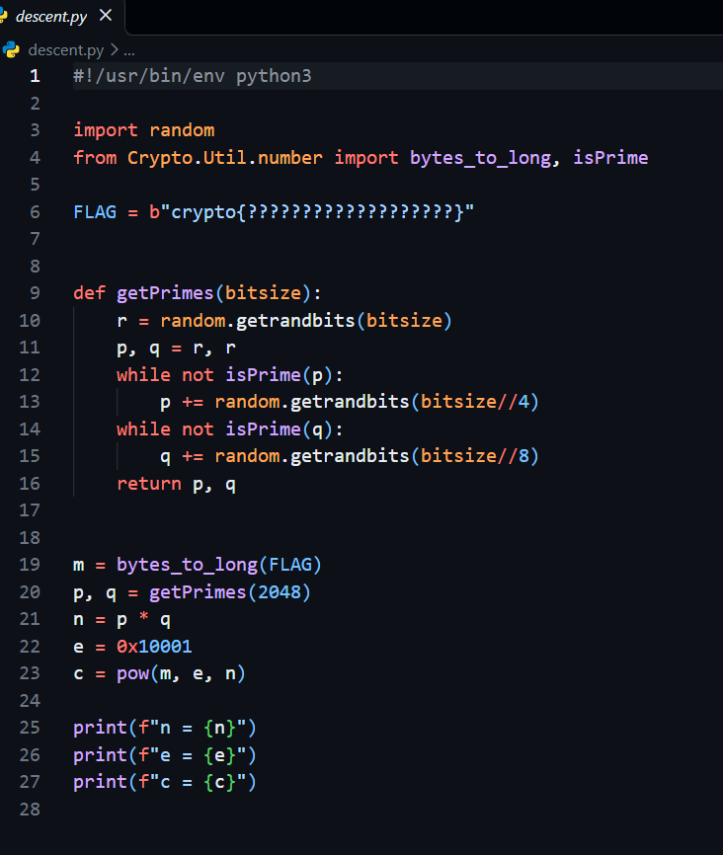
From the code I can understand, both p and q begin with same value r. The code then increases them independently until each becomes prime. Since both prime numbers originate from the same 2048-bit number, their difference is very small.
This is the vulnerability that needs to be exploited.

Exploitaion:
This challenge can be solved by Fermat’s Factorization because:
RSA generates a modulus using: n=pq
Fermat’s factorization uses the identity: n = a^2 – b^2 = (a-b) (a+b)
So, I need to find int a and b such that: a^2 – n = b^2
I can now recover the 2 factors: p=a-b, q=a+b
Since, p and q are too close, the initial value of a already satisfies the condition and so Fermat’s factorization succeeds on the very first attempt.

Flag recovery:
Output.txt contains RSA modulus n, public exponent e and ciphertext c.
I need to factor n to calculate the private exponent and then decrypt the ciphertext.
To do this I use the following solver script:
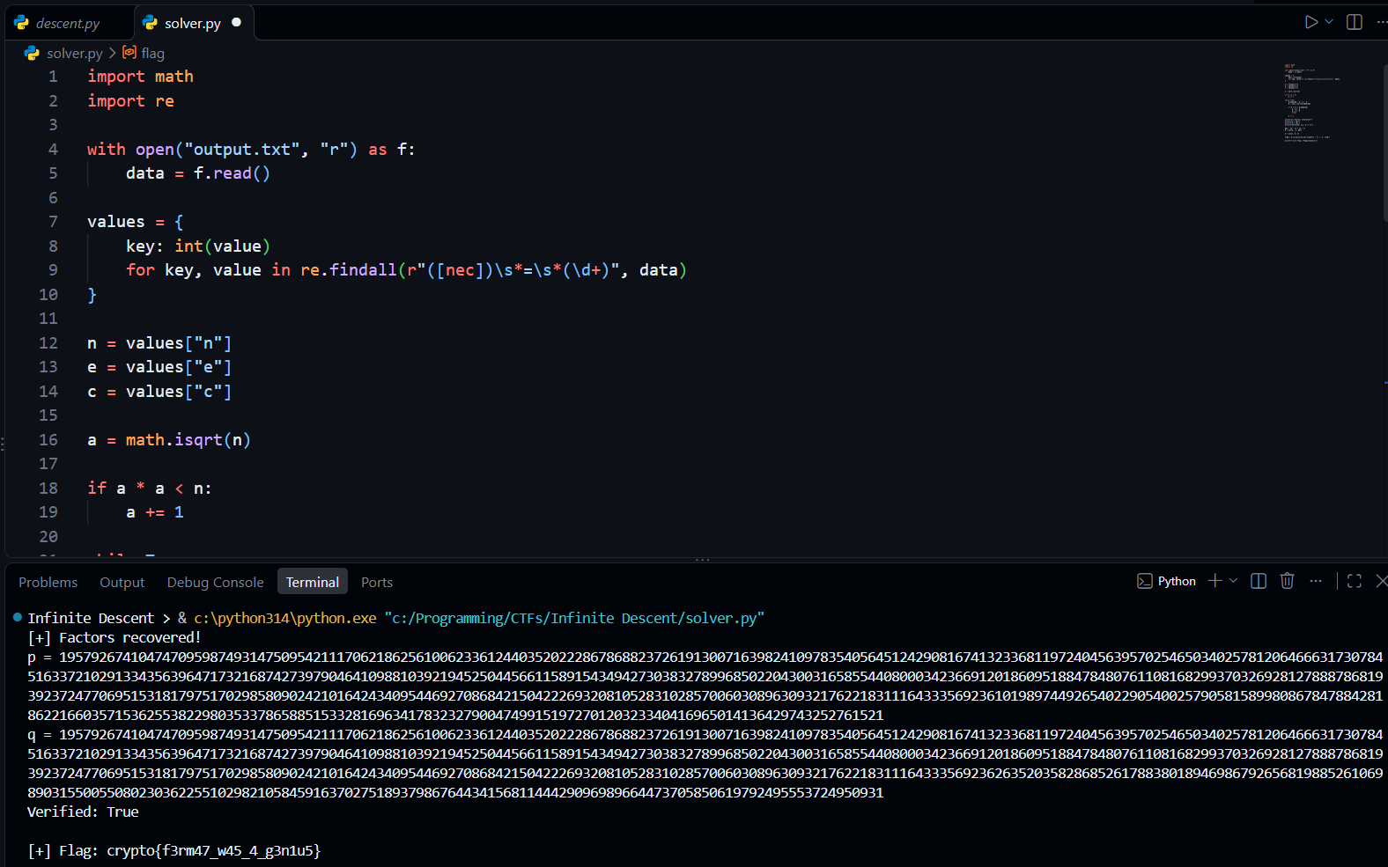
Final Flag: crypto{f3rm47_w45_4_g3n1u5}

